Exercise 1: Implementing the Singleton Pattern
Singleton Pattern
The Singleton Pattern is a creational design pattern that ensures only one instance of a class is created throughout the application lifecycle.
It is commonly used for:
- Logging utilities
- Database connections
- Configuration settings
- Cache management
Characteristics of Singleton Pattern
- Only one object of the class can exist.
- The constructor is declared as private.
- A static instance of the class is maintained.
- A public method provides access to the single instance.
Implementation
Logger.java
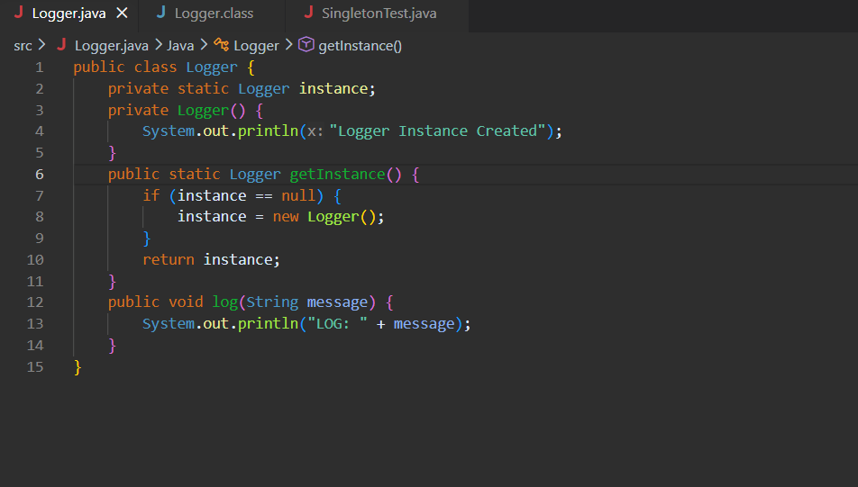

SingletonTest.java
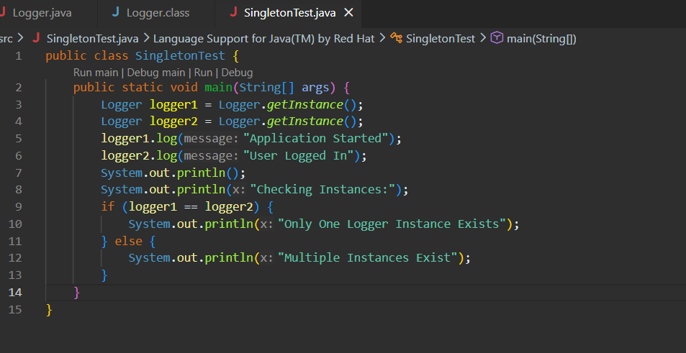

OUTPUT


Analysis
- The Singleton Pattern prevents multiple objects from being created.
- Memory usage is reduced because only one instance exists.
- Ensures consistent logging throughout the application.
- Provides a global access point to the Logger object.

